Basic Bringup of PLL-Evalboard-Synthesizer

Rich Rademacher, University of Waterloo/IQC

January 2018

# Introduction

This document describes the bring up of our Phase-Locked Loop (PLL) frequency synthesizer for generating medium-precision RF carrier wave (CW) signals. The Quantum Ion Trap group at the Institute for Quantum Computing (IQC) uses a series of evaluation boards from Analog Devices and Perigrine Semiconductor to provide a low-cost series of RF drive signals.

# Initial Bring Up of ADF41020 Evaluation Board

The evaluation board is shown below:

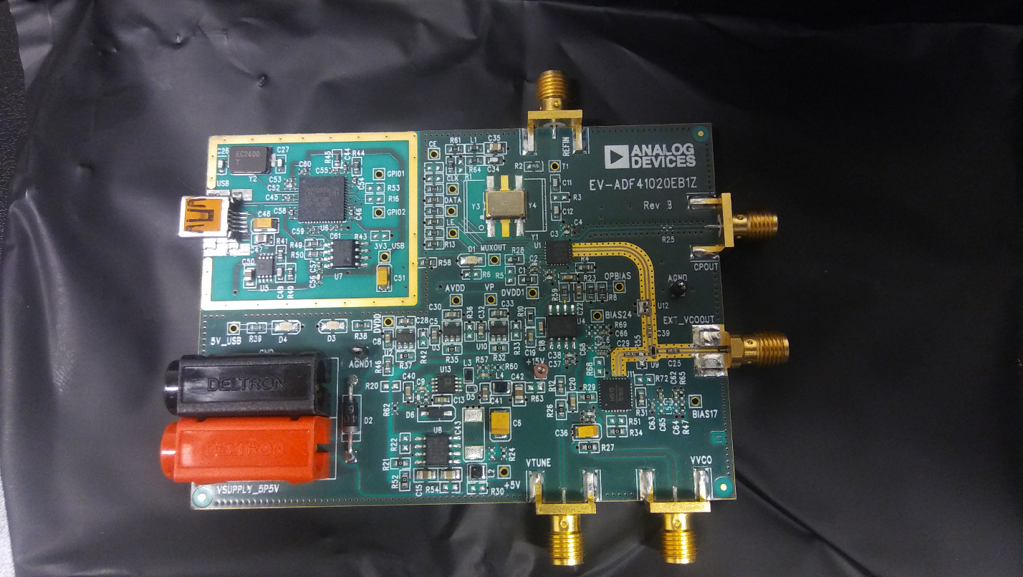

Figure 1 Microwave Synthesizer Showing Location of VCO

## Programming Software

The on-chip programming software from the ADI website is at <http://www.analog.com/media/en/evaluation-boards-kits/evaluation-software/ADI_Int-N.zip>. This software is required to operate the board without using the Raspberry Pi.

## Powering the EVB

An external power supply of +5.5V is required. USB power for communication is also required if not using the Raspberry Pi

# Initial Bring Up of ADF4355-2 Evaluation Board

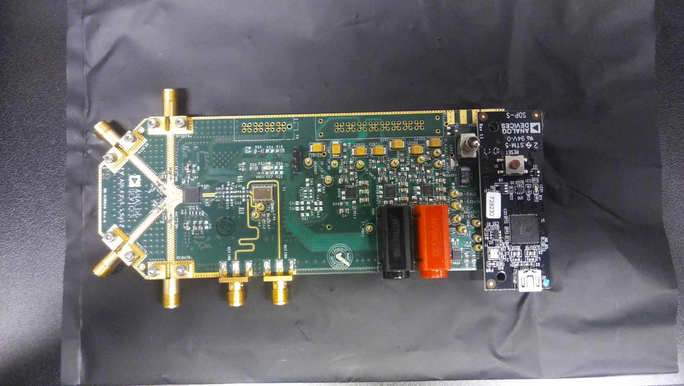

Figure 2 RF Synthesizer Board with USB Programmer Attached

## Programming Software

Programming software located at <http://www.analog.com/media/en/evaluation-boards-kits/evaluation-software/ADF4355_v1_2_3.zip>. This evaluation board must be connected to the SDP-S USB controller for standalone operation. The SDP-S is not required when using the Raspberry Pi.

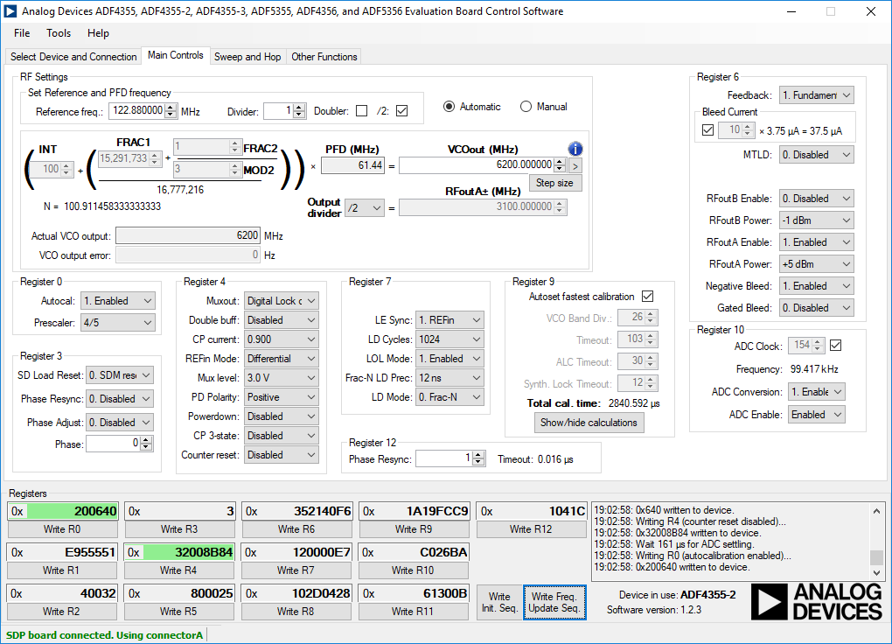

Figure 3 RF Synthesizer PC Programming Screen showing Frequency Reginsters and Programming Buttons

* The Initialization button must be pressed prior to programming the frequency
* The frequency button must be pressed after the initialization button to update frequency.
* Programming the frequency must take into account the limited range of the VCO on-board the PLL chip. Its range is 3.3 GHz to 6.8 GHz. Use the output divider to set the proper RFoutA frequency.

# Bring up of the Programmable Attenuator Board

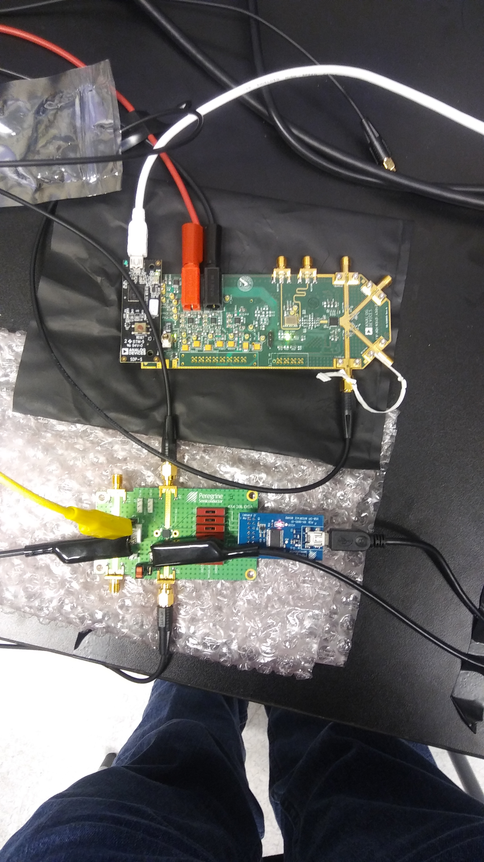

Figure 4 RF Synthesizer with Attenuator Board

The programming software for the Peregrine Semiconductor EK4312 evaluation board is at <http://www.psemi.com/products/digital-step-attenuators-dsa/pe4312>.

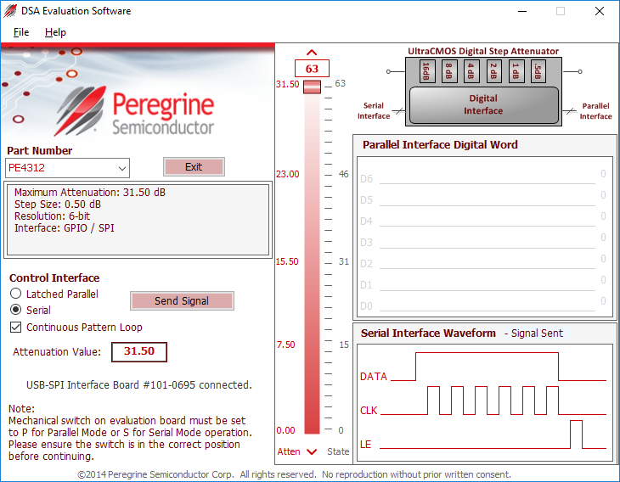

* Power supply for the Peregrine board requires 3.3V. The VDD and VDD_DIG connections on J9 should be connected using jumper JP3. The evaluation board manual makes mention of a negative supply of -3.3V on VSS but this can be set to GND for lab use.
* The VSS and GND connections should be shorted together using jumper JP1.
* The P/S switch J10 should be set to S for serial operation using the USB controller and SPI.

# Bring up of Raspberry Pi

The Raspberry Pi is shown below:

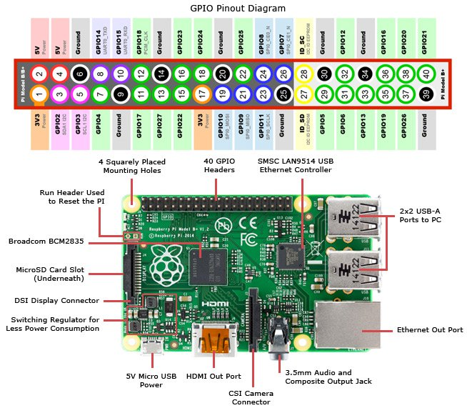

Figure 5 Raspberry Pi 3 with Pinout

* The Raspberry Pi 3 requires a new clean SD micro card
* Download Raspbian Stretch Lite from <https://raspberrypi.org/downloads/raspbian/>.
* Download Etcher from <http://etcher.io>.
* Unzip the Raspbian image (Etcher will not warn and does not unzip)
* Restore the Raspbian image to the SD card using Etcher
* Using local keyboard and mouse, log into the Raspberry Pi
  + User: pi
  + Password: raspberry
* Update runtime image using

sudo apt-get update  
sudo apt-get upgrade

* Enable SSH server  
   sudo raspi-config  
   Select Interfacing Options->SSH and enable
* Get the Git repository

sudo apt-get install git

sudo git clone “repository link”

## Installation of SPI-Dev for Python

* Install python development:  
  sudo apt-get install python-dev
* Enable SPI  
  sudo raspi-config  
  Select Peripherals->SPI and enable
* Reboot
* Download spi-dev packages  
  wget clone <https://github.com/doceme/py-spidev/archive/master.zip>  
  unzip master.zip  
  cd py-spydev-master
* Build and install   
  python setup.py build  
  sudo python setup.py install

## Installation of GPIO Zero for Python

Sudo apt install python3-gpiozero

## Example Test Program

#!/usr/bin/python

###### Test program for SPI #####

import spidev

import time

spi = spidev.SpiDev()

spi.open(0,0)

spi.max_speed_hz = 7629

while True:

spi.xfer([0x1,0xff])

time.sleep(0.5)

spi.xfer([0x0, 0x0])

time.sleep(0.5)

# Bringup of ADF4355 Eval board

## Build adapter cable

|  |  |  |
| --- | --- | --- |
| **Raspberry Pi Pin** | **ADF4355 Pin** | **Function** |
| 23 | TP 3 | SPI_SCLK |
| 19 | TP 4 | SPI_MOSI |
| 26 | TP 5 | SPI_LE1 |
| 20 | VSUPPLY Connector Fence | Ground |

## 

## Location of SPI Contacts

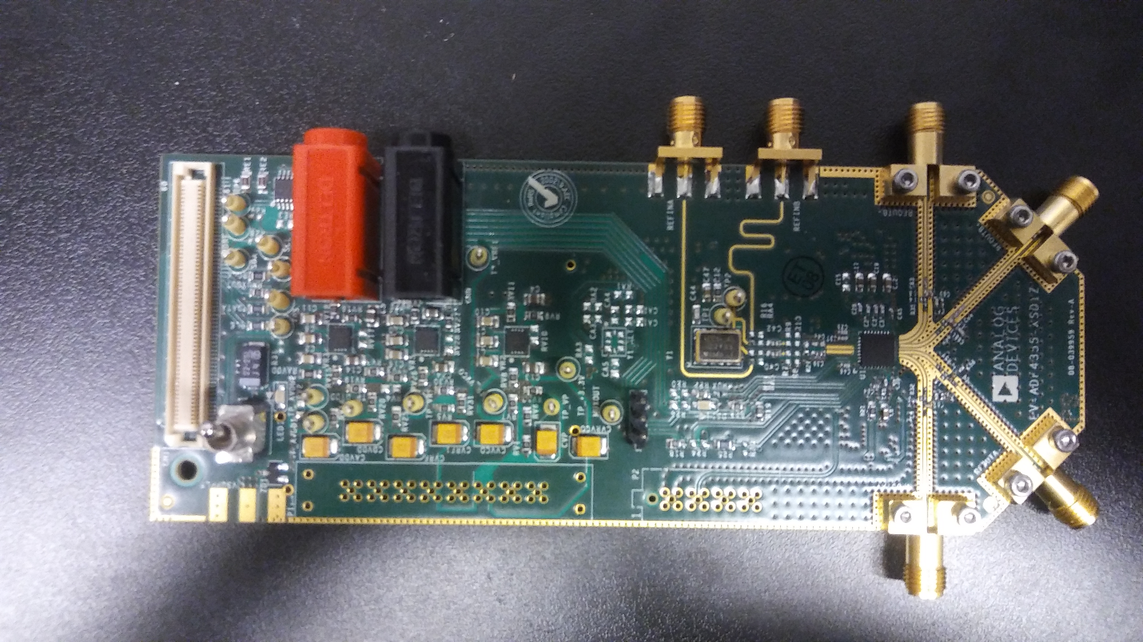

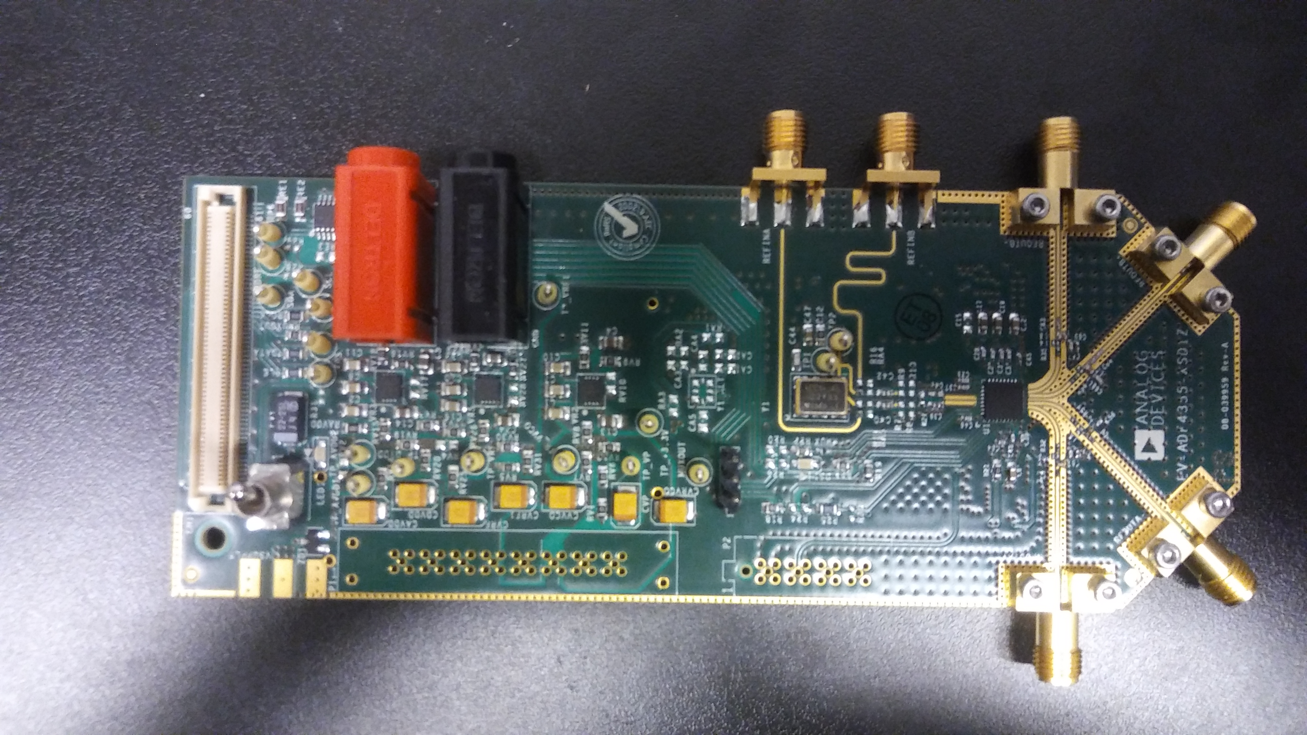

GND on Fence Pad

TP5 SPI LE1

TP4 SPI MOSI

TP3 SPI CLK

# Multiple Device Control

Since there is only one Chip Enable on each Raspberry Pi, it is better to use the multi-purpose GPIO’s so that one Pi can control many devices. In the pinout of the RPi, any of the green GPIO’s can be used for this purpose. These GPIO’s will be held high, then brought low for loading the shift registers of a device, then brought high to latch in the data.

By connecting all devices to the common CLK and MOSI(DATA) line, and each to its own GPIO, we can control all of them.

To use the GPIO, the LatchEnable function in the LatchEnable.py file is called with the GPIO pin number as the argument. This uses the RPi.GPIO library to control the voltage output of the pin. Use the following code to set up the GPIO:

#Pin numbering type BCM

GPIO.setmode(GPIO.BCM)

GPIO.setup(GPIOpin, GPIO.OUT)

#Set as true always unless latching.

GPIO.output(GPIOpin, True)

Now you can change the output of the GPIO however needed for whichever device you are latching.